**Q:2** Generate a model in Python to represent a Housing loan scheme and create a chart to display the Emi based on rate of interest and reducing balance for a given period. If a customer wishes to close the loan earlier, print the interest lost distributed over the remaining no. Of months. Assume suitable data and inputs as necessary.

**Solution:** EMI calculation and loan schedule plot.

Here’s Python code calculates EMI for a housing loan, generates a repayment schedule, and plots a chart showing interest, principal paid, and remaining balance over the loan term.

**Code:**

|  |
| --- |
| import numpy as np  import matplotlib.pyplot as plt  def calculate_emi(principal, annual_rate, months):      monthly_rate = annual_rate / 12 / 100  # converting annual rate to monthly rate      emi = principal * monthly_rate * ((1 + monthly_rate) ** months) / (((1 + monthly_rate) ** months) - 1)      return emi  def generate_loan_schedule(principal, annual_rate, months):      schedule = []      monthly_rate = annual_rate / 12 / 100      remaining_balance = principal        for month in range(1, months + 1):          interest = remaining_balance * monthly_rate          principal_payment = calculate_emi(principal, annual_rate, months) - interest          remaining_balance -= principal_payment          schedule.append((month, interest, principal_payment, remaining_balance))        return schedule  def plot_loan_schedule(schedule):      months = [entry[0] for entry in schedule]      interest_paid = [entry[1] for entry in schedule]      principal_paid = [entry[2] for entry in schedule]      remaining_balance = [entry[3] for entry in schedule]        fig, ax1 = plt.subplots()      ax1.set_xlabel('Month')      ax1.set_ylabel('Amount ($)')      ax1.plot(months, interest_paid, 'b-', label='Interest Paid', linewidth=2)      ax1.plot(months, principal_paid, 'g-', label='Principal Paid', linewidth=2)      ax1.tick_params(axis='y')        ax2 = ax1.twinx()      ax2.set_ylabel('Remaining Balance ($)')      ax2.plot(months, remaining_balance, 'r--', label='Remaining Balance')      ax2.tick_params(axis='y')        fig.tight_layout()      fig.legend(loc='upper right')      plt.title('Loan Payment Schedule')      plt.show()  # Example usage  principal = 200000  # principal amount of the loan  annual_rate = 8.5  # annual interest rate (in percent)  months = 12 * 20  # 20 years loan term  emi = calculate_emi(principal, annual_rate, months)  print(f"EMI: ${emi:.2f} per month")  loan_schedule = generate_loan_schedule(principal, annual_rate, months)  plot_loan_schedule(loan_schedule) |

**Output:**

**EMI: $1735.65 per month**

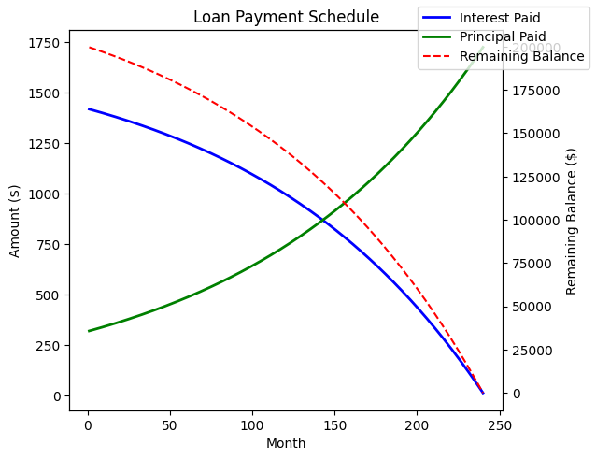

**Q:3** Generate a model for an insurance company to hold information on the insurer's vehicle, and create a chart of monthly, yearly, and quterly premiums based on no. of years of insurance where in each year, the value of the vehicle depreciates by 7%.

**Solution:** Insurance Model with Depreciation and Premium Calculation

Here’s a Python model that holds information about an insurer’s vehicle and calculates monthly, quarterly, and yearly premiums based on the vehicle's depreciation over the years.

**Code:**

|  |
| --- |
| import matplotlib.pyplot as plt    class VehicleInsurance:  def __init__(self, owner_name, vehicle_value, insurance_years, annual_premium_rate):  self.owner_name = owner_name  self.initial_value = vehicle_value  self.current_value = vehicle_value  self.insurance_years = insurance_years  self.annual_premium_rate = annual_premium_rate  self.premiums = {}    def calculate_depreciation(self):  for year in range(1, self.insurance_years + 1):  depreciation = self.current_value * 0.07 # 7% depreciation each year  self.current_value -= depreciation  annual_premium = self.current_value * self.annual_premium_rate / 100  monthly_premium = annual_premium / 12  quarterly_premium = annual_premium / 4  self.premiums[year] = {  "Annual": annual_premium,  "Quarterly": quarterly_premium,  "Monthly": monthly_premium  }    def display_premiums(self):  print(f"Premiums for {self.owner_name}'s vehicle:")  for year, premium in self.premiums.items():  print(f"Year {year}: Annual: {premium['Annual']:.2f}, Quarterly: {premium['Quarterly']:.2f}, Monthly: {premium['Monthly']:.2f}")    def plot_premiums(self):  years = list(self.premiums.keys())  annual_premiums = [self.premiums[year]['Annual'] for year in years]  quarterly_premiums = [self.premiums[year]['Quarterly'] for year in years]  monthly_premiums = [self.premiums[year]['Monthly'] for year in years]    plt.plot(years, annual_premiums, label='Annual Premium')  plt.plot(years, quarterly_premiums, label='Quarterly Premium', linestyle='--')  plt.plot(years, monthly_premiums, label='Monthly Premium', linestyle=':')  plt.xlabel('Years')  plt.ylabel('Premium Amount')  plt.title('Vehicle Insurance Premium Over Time')  plt.legend()  plt.show()    # Example usage  vehicle_insurance = VehicleInsurance(owner_name="John Doe", vehicle_value=500000, insurance_years=5, annual_premium_rate=5)  vehicle_insurance.calculate_depreciation()  vehicle_insurance.display_premiums()  vehicle_insurance.plot_premiums() |

**Output:**

